# 1. What Is Software Testing?

Software testing is a crucial process in the development of software applications. That is used to identify the correctness, completeness and quality of the developed software.

# 2. What is SRS?

A Software Requirement Specification (SRS) is a complete description of the behavior of the system to be developed.

Types of Requirements: Customer Requirement, Functional Requirement, Non-Functional Requirement.

# 3. What is oops?

"OOPs" stands for Object-Oriented Programming (OOP), which is a programming paradigm based on the concept of "objects.

These basic concepts form the foundation of Object-Oriented Programming and are used to create modular, reusable, and maintainable software systems.

# 4. Write Basic Concepts oops?

The main idea behind object-oriented programing, oops concept include abstraction, encapsulation, inheritance and polymorphism.

# 5. What is object?

An object is the basic unit of OOP which is accessed by its properties.

# 6. What is class?

Class is a blueprint or a template to describe the properties and behavior of the objects.

# 7. What is encapsulation

Encapsulation is the binding of data and methods that manipulate them into a single unit such that the sensitive data is hidden from the users.

# 8. What is inheritance

One class (Super, Base) inherits the properties of another class (Sub, Derived).

Types of Inheritance:

Single Inheritance

Multilevel Inheritance

Hierarchical Inheritance

Hybrid Inheritance

Multiple Inheritance

# 9.What is polymorphism

The word “Polymorphism” means having many forms. It is the property of some code to behave differently in different contexts.

# 10. What is SDLC

SDLC is a methodology or step-by-step approach to produce software with high quality, lowest cost in the shortest possible time by defining the phases like Planning, Analysis & Design, Coding & Implementation, and Testing & Maintenance.

11. Draw Use case on Online book shopping

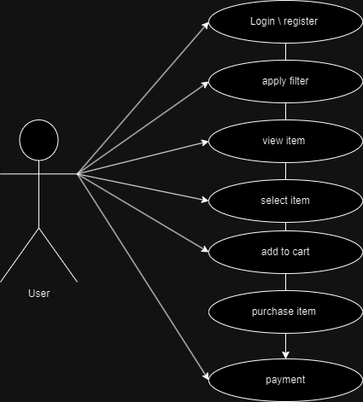

# 12. Write SDLC phases with basic introduction

1. Requirements Collection/Gathering

Three types of problems can arise

Lack of clarity, Requirement confusion, Requirement Amalgamation

2. Analysis

3. Design (Low Level Design & High-Level Design)

4. Implementation / Coding

5. Testing

6. Maintenance

# 13.Draw Use case on online bill payment system (paytm)



# 14. Draw use case on Online shopping product using COD.

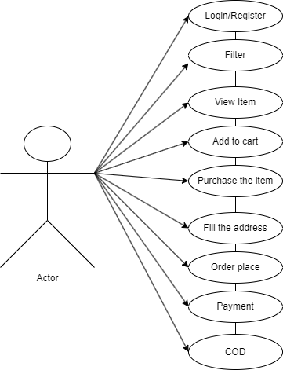

# 5. Draw use case on Online shopping product using payment gateway

# 

# 16.Explain Phases of the waterfall model

The waterfall model is a classical software lifecycle that models the software development as a step-by-step “waterfall” between the various development phases.

Requirement collection

Maintenance

Analysis

Analysis

Analysis

Design

implementation

Analysis

Testing

Analysis

In waterfall model process reversing is impossible so we go only

Up to down like waterfall.

# 17.Write phases of spiral model.

Spiral modal has four phases.

* **Planning :**  determining of objectives, *alternatives* and constraints.
* **Risk Analysis :** *analysis of alternatives and identification/resolution of risks.*
* **Engineering :** Development of the next level product.
* **Customer** **Evaluation :** *assessment of the result of engineering.*

# 18.Write agile manifesto principles

Individuals and interactions over processes and tools

Working software over comprehensive documentation

Customer collaboration over contract negotiation

Responding to change over following a plan

# 19. Explain working methodology of agile model and also write pros and cons.

“Agile SDLC model is a combination of iterative and incremental process models with focus on process adaptability and customer satisfaction by rapid delivery of working

**Pros:**

1. Very realistic approach
2. Rapid delivery.
3. Functionality can be developed rapidly
4. Resource requirements are minimum.
5. Little or no planning required
6. Promotes teamwork and cross training.
7. Suitable for fixed or changing requirements
8. Gives flexibility to developers

**Cons**:

1. More risk of sustainability, maintainability and extensibility.
2. Depends heavily on customer interactions.
3. Very high individual dependency.
4. Minimum documentation generated.
5. Not useful for small projects.
6. Not suitable for handling complex dependencies.

# 20.What is agile methodology?

Agile SDLC model is a combination of iterative and incremental process models with focus on process adaptability and customer satisfaction by rapid delivery of working software product.

Prepared by – sachin